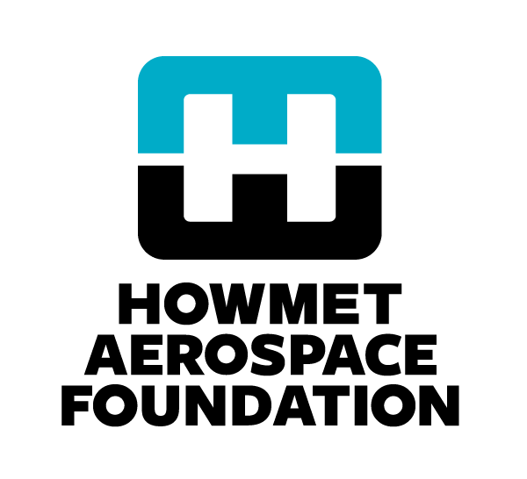
Grant Application Guidance and Example Answers

What is your organization’s mission?

Guidance: Mission is what you do; mission statements should be short and clear. Describe how your mission gives you focus and guides your actions and decisions.
Example: The Iowa Community College Foundation (ICCF) mission is to provide accessible quality educational programs and services to meet personal and community needs and expectations. Our mission guides the programs we offer and to whom; it incorporates the aspects of both productivity and quality of life into our students’ goals and the curriculum we offer.

Describe the challenge or opportunity you intend to address either internally within your organization or externally for the larger community (local, national or global). Describe the change or improvement you seek to realize.

Guidance: State the challenge or problem you are trying to address in clear terms as it is experienced by the community (described as people or places) which is affected. Focus on the set of people, organizations or environmental elements in the geographic area you serve to explain the community issues that support the need for the proposed project. If your program is designed to impact a geographic site or sites rather than a population of people -- as in a land reclamation project -- describe the place(s) here and in the following questions.
How are the characteristics of the people or places you will reach directly through this project different from the full set of people or places who are facing this issue within the larger community you serve?
Example: An ongoing concern in the local Quad Cities community is that many low-income and/or minority students do not perform well in school, which has a negative impact on their ability to obtain quality jobs and life opportunities. There is currently a documented 15-point gap between overall Quad Cities’ high school student achievement rates in the last ten years compared to all other low-income and/or minority students in our state. Many former at-risk students get married and have children early in life increasing their need for stable income and reducing the time available for ongoing academic or technical training. Many do not have or use a budget and live paycheck to paycheck in order to pay the bills and feed the family. The proposed program will give those former at-risk students who have not obtained or qualified for good jobs in the manufacturing sector a second chance to build their academic, management and life skills.
Our primary focus is on potentially qualified workers over the age of 23 who were identified as “at-risk” students during their high school careers due to low socio-economic or minority status and who do not currently have the skills or job training to enable them to obtain higher level manufacturing positions for companies within the Quad Cities community. Most of them are still in entry level jobs or jobs that require only basic technical, organizational or interpersonal skills. Less than 2% have management or leadership skills or experience. A prevailing attitude for many is a sense of ‘this is as good as it gets’, and they have had little inspiration or encouragement from others to move up in life.

Identify the major activities which are planned, and which must be completed for this project to be considered a success. Note: All activities should occur between the project start and end dates.

Guidance: A strong answer to this question includes:
- activity milestones that clearly reflect 2 - 5 key progress points that participants should reach to be 'on track' to achieve the project results (e.g. participants enroll, they demonstrate new skills, they use skills on their own, they achieve the program target)
- critical steps that include only the major activities that are required to move the organization or participants to each progress point (e.g. provide outreach, provide training, provide 1:1 counseling, provide follow-up and verification)
- a clear IF - THEN relationship between a major project activity and the quantitative result that defines success for that activity (e.g. IF we provide outreach, THEN at least 100 new participants will enroll in the program)
- a timeline that reflects when a milestone will be accomplished - not when the activity will be implemented.

Click here for a workbook to help you create a strong set of steps and milestones.

Example:

1) Develop course outline aimed at closing gaps of target population in workplace and skill development and present to ten local manufacturing companies.
Milestone: At least six local manufacturing companies will participate in focus groups to confirm gaps in workplace and skill development and agree to consider promotions for employees who graduate (June-July YYYY).

2) Work with head of department, professors and manufacturing company representatives to develop and finalize curriculum.
Milestone: Curriculum completed and educators demonstrate their ability to deliver the new material (July YYYY).

3) Market to and recruit students from each of the focus group participating companies and other local manufacturing facilities.
Milestone: At least 15 students will enroll for the fall semester (August-September YYYY).

4) Deliver the first ten-week series and meet with four manufacturing companies to identify job opportunities for graduates.
Milestone: At least ten students will successfully graduate and at least two companies will identify clear job opportunities for their employees (September YYYY-January YYYY).

5) Provide counseling for fall semester graduates and deliver the second ten-week series.
Milestone: At least 12 students will successfully graduate (January – May YYYY).

